**Project Design Phase**

**Problem – Solution Fit Template**

|  |  |
| --- | --- |
| Date | 6 March 2025 |
| Team ID | SWTID1741256970149949 |
| Project Name | Rhythmic Tunes |
| Maximum Marks | 2 Marks |

**Problem – Solution Fit Overview:**

The **Problem-Solution Fit** ensures that the identified problem aligns with the needs of music listeners and that the proposed solution effectively addresses it. This validation is crucial before further development.

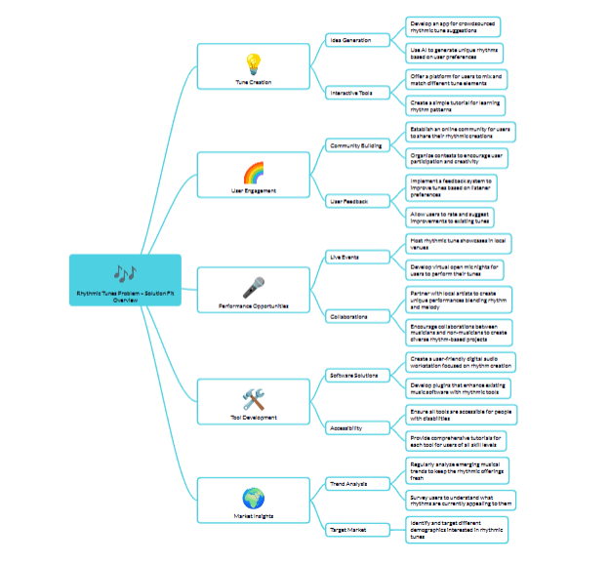

**Purpose:**

The purpose of a Problem – Solution Fit Overview is to clearly define the core challenges your target users face and demonstrate how your solution directly addresses those challenges. This overview validates that the proposed product not only fills a gap in the market but also offers tangible value to its users. It’s a strategic alignment tool that informs product development, ensuring every feature and technical decision is driven by the underlying need.

### **Problem Statement:**

Many music enthusiasts face challenges in finding a single platform that offers:

* A vast and diverse music library.
* Accurate and personalized music recommendations.
* Reliable offline listening capabilities.
* A strong social community around music.
* Fair exposure for independent artists.

### **Solution:**

· **High-Quality Streaming:**  
Delivers smooth and reliable audio playback, ensuring every note and beat is heard as intended—much like a well-rehearsed performance.

· **Personalized Music Discovery:**  
Uses intelligent recommendation systems to help users discover new artists and tracks, turning the process into a curated, engaging experience.

· **User-Friendly Interface:**  
Provides an intuitive design that makes navigation and interaction simple, so users can focus on enjoying their music rather than managing complex controls.

· **Robust Performance and Security:**  
Ensures data integrity, security, and seamless performance, much like the steady rhythm that holds a musical performance together.